Food Finder Documentation

Wireframes/Story Board

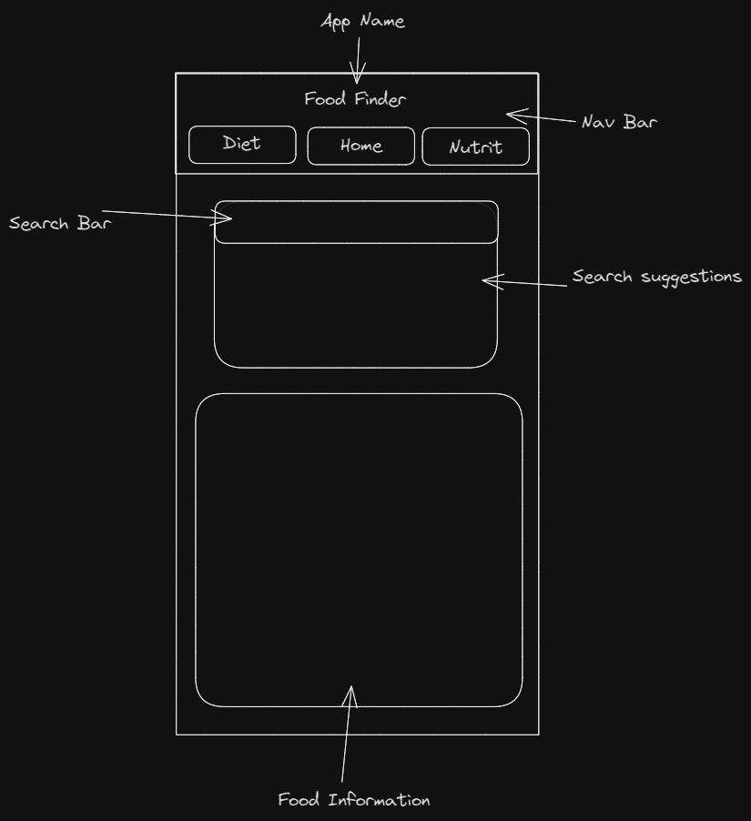

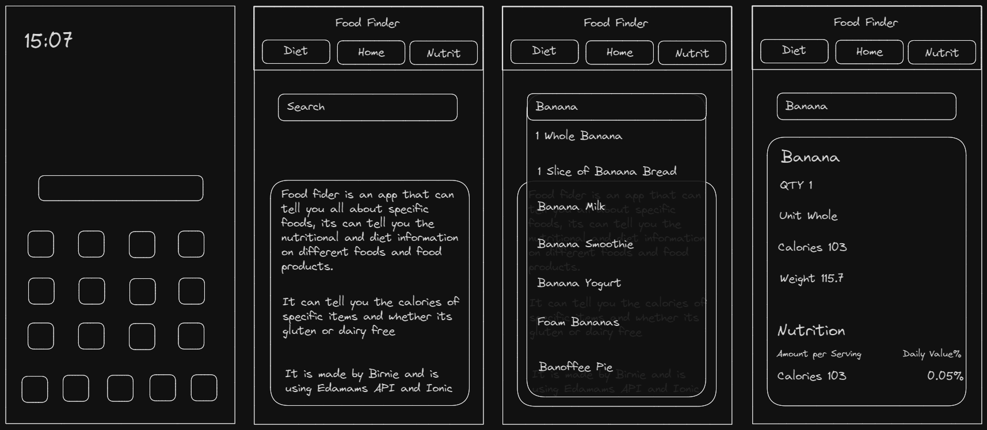

Testing Table

|  |  |  |  |  |
| --- | --- | --- | --- | --- |
| Test | Expected Result | Actual Result | Pass/Fail | Corrective Action |
| App name displayed | App name is displayed at top of screen (All Screens) | As Expected | Pass | N/A |
| Buttons display | Three buttons display at the top of the screen  (All Screens) | They did display just one underneath the other | Fail | Changed it so they were in a grid instead to format them better (used grid on everything from this point forward) |
| Page Display | The name of the page you're on is displayed  (All Screens) | Displayed but it was below the image | Fail | Moved the page display code up so that it was above the image |
| Home Button | Home button when clicked takes you to the correct page  (All Screens) | Nothing happened when clicked | Fail | Forgot to add the href to the buttons, added correct href |
| Diet Button | Diet button when clicked takes you to the correct page  (All Screens) | As Expected | Pass | N/A |
| Nutrition Button | Nutrition button when clicked takes you to the correct page  (All Screens) | As Expected | Pass | N/A |
| Text Display | Text is properly displayed on page  (All Screens) | As Expected | Pass | N/A |
| Image Display | Image is displayed underneath page display  (Home and Diet Page) | Nothing displayed | Fail | Forgot to put the full stop in the image source  ./Pictures/Diagram.png  Fixed by putting full stop in |
| Info Button | More info button on diet page takes you to external link  (Diet Page) | As Expected | Pass | N/A |
| Cal Input | Typing on the calorie input bar  (Home Page) | As Expected | Pass | N/A |
| Cal Button | Accepts your calorie input from bar  (Home Page) | As Expected | Pass | N/A |
| Cal Display | Displays inputted cal count  (Nutri Page) | As Expected | Pass | N/A |
| Food Bar | Typing on the food input bar  (Nutri Page) | As Expected | Pass | N/A |
| Search Button | Accepts your food input from bar  (Nutri Page) | As Expected | Pass | N/A |
| Food Display | Displays inputted food search  (Nutri Page) | As Expected | Pass | N/A |

Use of Ai

I used Ai to create the two images that are in my app

They were created from the Midjourney bot in discord

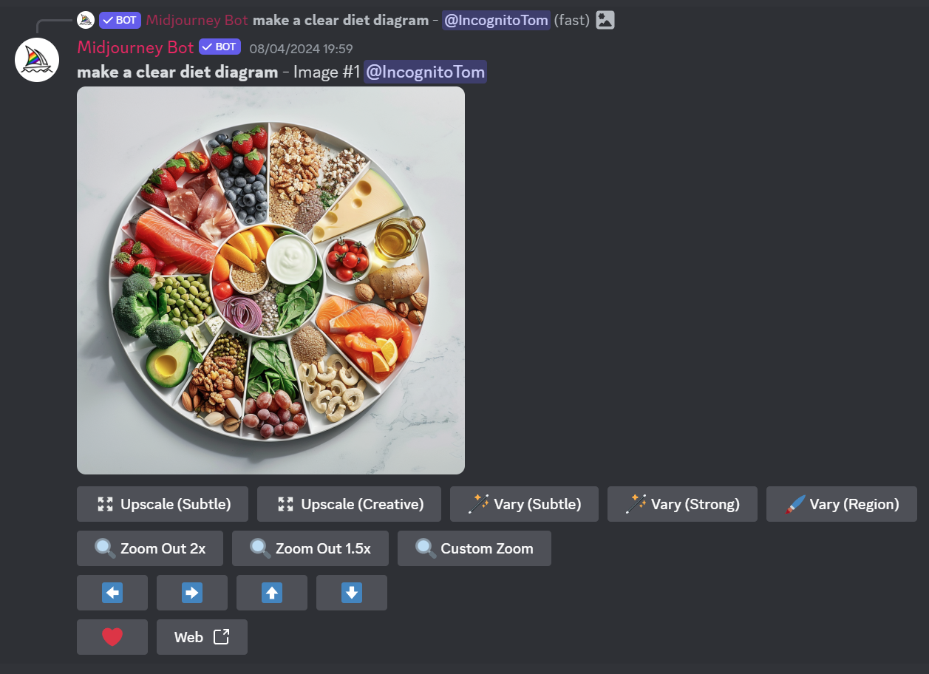

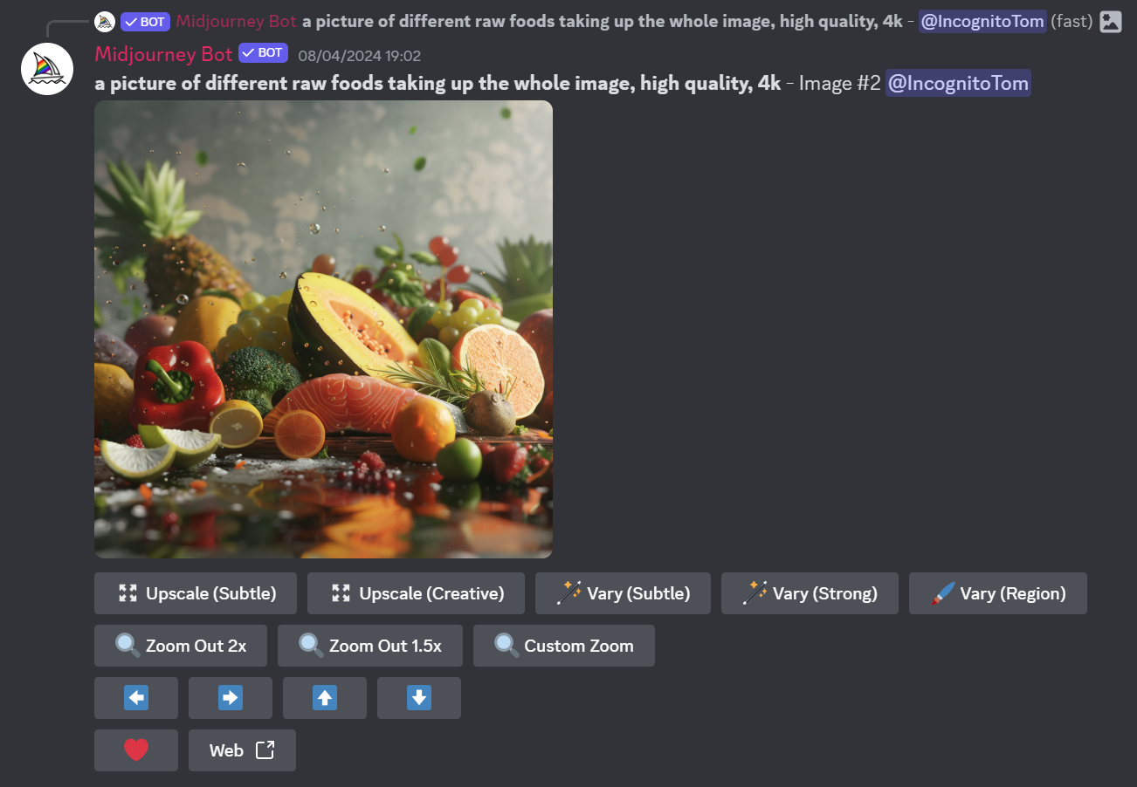

References

World Health Organization. (N/A). *Healthy diet*. [Online]. World Health Organization. Last Updated: N/A. Available at: https://www.who.int/initiatives/behealthy/healthy-diet#:~:text=A%20healthy%20diet%20is%20essential,a [Accessed 8 April 2024].

Spoonacular. (N/A). *The only food API you'll ever need*. [Online]. Spoonacular API. Last Updated: N/A. Available at: https://spoonacular.com/food-api [Accessed 1 April 2024].